***D1***

Discuss features that can improve the readability of code.

Include in your submission references to:-

* descriptive variable names
* consistent notation
* line breaks and white space
* comments
* indentation
* segmentation

**Descriptive variable names-** this variable will need to be as descriptive as possible, because this variable can save time as much as possible. On the other hand, the overall appearance and the quality of the programme is improved.

Some examples of descriptive variable names could be:

* TotalCost
* totalCostWithTax
* numCols
* numRows
* colourCircle
* rectWidth

***These named above are only some examples of descriptive variable names.***

[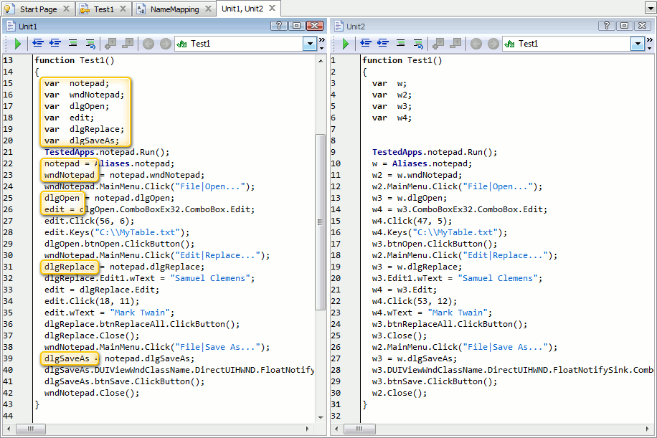](http://www.google.co.uk/url?sa=i&rct=j&q=&esrc=s&frm=1&source=images&cd=&cad=rja&docid=jfQTO20RXc-vEM&tbnid=zxiWMJRVLdDhrM:&ved=0CAUQjRw&url=http://blog.smartbear.com/software-quality/testcomplete-7-improvements-automated-test-recording/&ei=RolFUtrLF5KA7Qa9-4HIAQ&psig=AFQjCNHVMczpqgK7EYQ2x-PuCy-KKjcA9Q&ust=1380375235746583)Variable names are identifiers. For example Java has rules for variables, if the rules are not followed Java complain. This means you need to be able to write the correct definition in order for it to be successful.

**Consistent Notation**

Consistent notation consists of two types of notation. They is two types of notation are:

* Camel Notation
* Hungarian notation

**Hungarian notation** is an identifying naming convention in programming that is given a variable where it identifies it’s a purpose of use.

Features that can improve the readability of this code can be consistency is improvement for the variables as this can improve the readability of the code. It is important not to edit the variables as it will be hard to really hard to understand and read.

[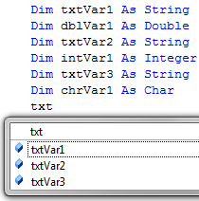](http://www.google.co.uk/url?sa=i&rct=j&q=&esrc=s&frm=1&source=images&cd=&cad=rja&docid=7-6hklIQPxoidM&tbnid=hf4HGnzdB1_4ZM:&ved=0CAUQjRw&url=http://visualbasic.about.com/b/2009/11/20/hungarian-notation-revisted.htm&ei=BdxKUvPTFOnn7Ab0soDICw&bvm=bv.53371865,d.ZGU&psig=AFQjCNGIY4t1ke5od70Fs1adItVPQl357g&ust=1380724039659683)An example can be the following picture. These are abbreviated in the computing language as it’s known as in the picture.

**Camel Notation**

This is referred to as the “camel” notation, because once this is used, it removes all the spaces making it look like a camel’s hump. This can improve the readability of the code by enhancing the description of the code such as “end of file” or char table”.

This notation can be written as, in programming:

***“My $camelcase = "This is a test.";   
$camelcase =~ s/ ([a-z])/\u$1/g;”***

Some examples of camel notation can be:

* BumpyCap
* camelBack notation
* CamelCap
* CapitalizedWords or CapWords for upper camel case in Python
* compoundName
* Embedded Caps (or Embedded Capitals
* HumpBack notation

**Line breaks and white spaces-** In programming, this is the spaces and line breaks where it makes it easier for the code to understand. It causes spaces in between the codes to make it easier. However, the line breaks can be broken. Also, putting spaces for the code could make another person confused to understand the code.

[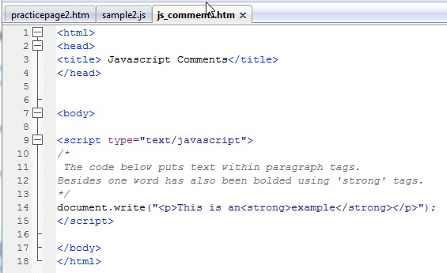](http://www.google.co.uk/url?sa=i&rct=j&q=&esrc=s&frm=1&source=images&cd=&cad=rja&docid=P88OJPfyL_Lo6M&tbnid=VkhhYNeUuMNZfM:&ved=0CAUQjRw&url=http://www.brucerick.com/dont-forget-comments-when-programming.html&ei=vOFKUt7MEvHB7AbeoIGIDA&bvm=bv.53371865,d.ZGU&psig=AFQjCNG5ZM7rxjlxlF9-LJCnS_1-bWEvYg&ust=1380725562047038)

**This is an example and as you can see codes in between have spaces.**

**Comments**

As you can see the picture above shows an example of a comment used in a HTML. There are comments where text has been shown. Comments are usually embedded in the programme for the programme to make it easier to understand. The comments are usually embedded into the source of code by using these symbol ‘{‘. These symbol is the start of the comment and ‘}’ the end of the comment. This helps the readability of the code as one these symbols appear it helps the reader understand where the comment is placed. The picture above, it shows an example of the comment. This picture below shows where the comment is embedded. The highlighted part is the comment. Some forms of programmes uses different types of symbols.

[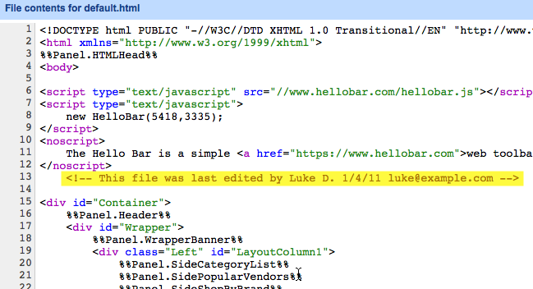](https://www.google.co.uk/url?sa=i&rct=j&q=&esrc=s&frm=1&source=images&cd=&cad=rja&docid=S7PurqPN-5L8QM&tbnid=djXVzpukkuWruM:&ved=0CAUQjRw&url=https://support.bigcommerce.com/questions/1233/&ei=yRdUUuveEYTA7Aad2YCgDA&bvm=bv.53537100,d.ZGU&psig=AFQjCNGInCey8NqzsXu7bF7B8_j-Q-PWJw&ust=1381329223596547)

[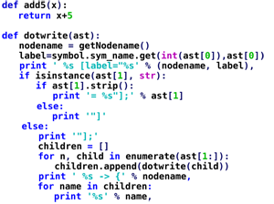](http://www.google.co.uk/url?sa=i&rct=j&q=&esrc=s&frm=1&source=images&cd=&cad=rja&docid=gEDMvncYHS0nyM&tbnid=CCOFUMgtcuk2tM:&ved=0CAUQjRw&url=http://www.host-shopper.com/learn-about-python.html&ei=zZVOUtaVHfSu7AavqICgBA&bvm=bv.53537100,d.ZGU&psig=AFQjCNE6ugO7_AZ9ssdYACLKnEnKTVHPUQ&ust=1380968267714939)

**Indentation**

Indentation is the separating of paragraphs. It is the beginning of a line to signal the new start of a paragraph. This is important as it’s not all together like a sentence. It separates it. For example as it’s highlighted on the picture, it’s separated from each of the codes. If another person read this code it would be very confusing, if it was all conjured into one piece. As well as separating the codes, this is used to format program source code to improve readability. This is generally only used in programming. However, certain programmes rely only on indentation to fix the structure.

**Segmentation**

Segmentation is where codes are seperated so its not confusing the user. It seperates all the code of the input of the codes to the output of the codes. Some layout can be different. This is important as this improves the readability of the code by seperating the codes. For example if all the codes is on one place then it would look confusing for another user.

This picture below can be the an example of all the codes smushed together.

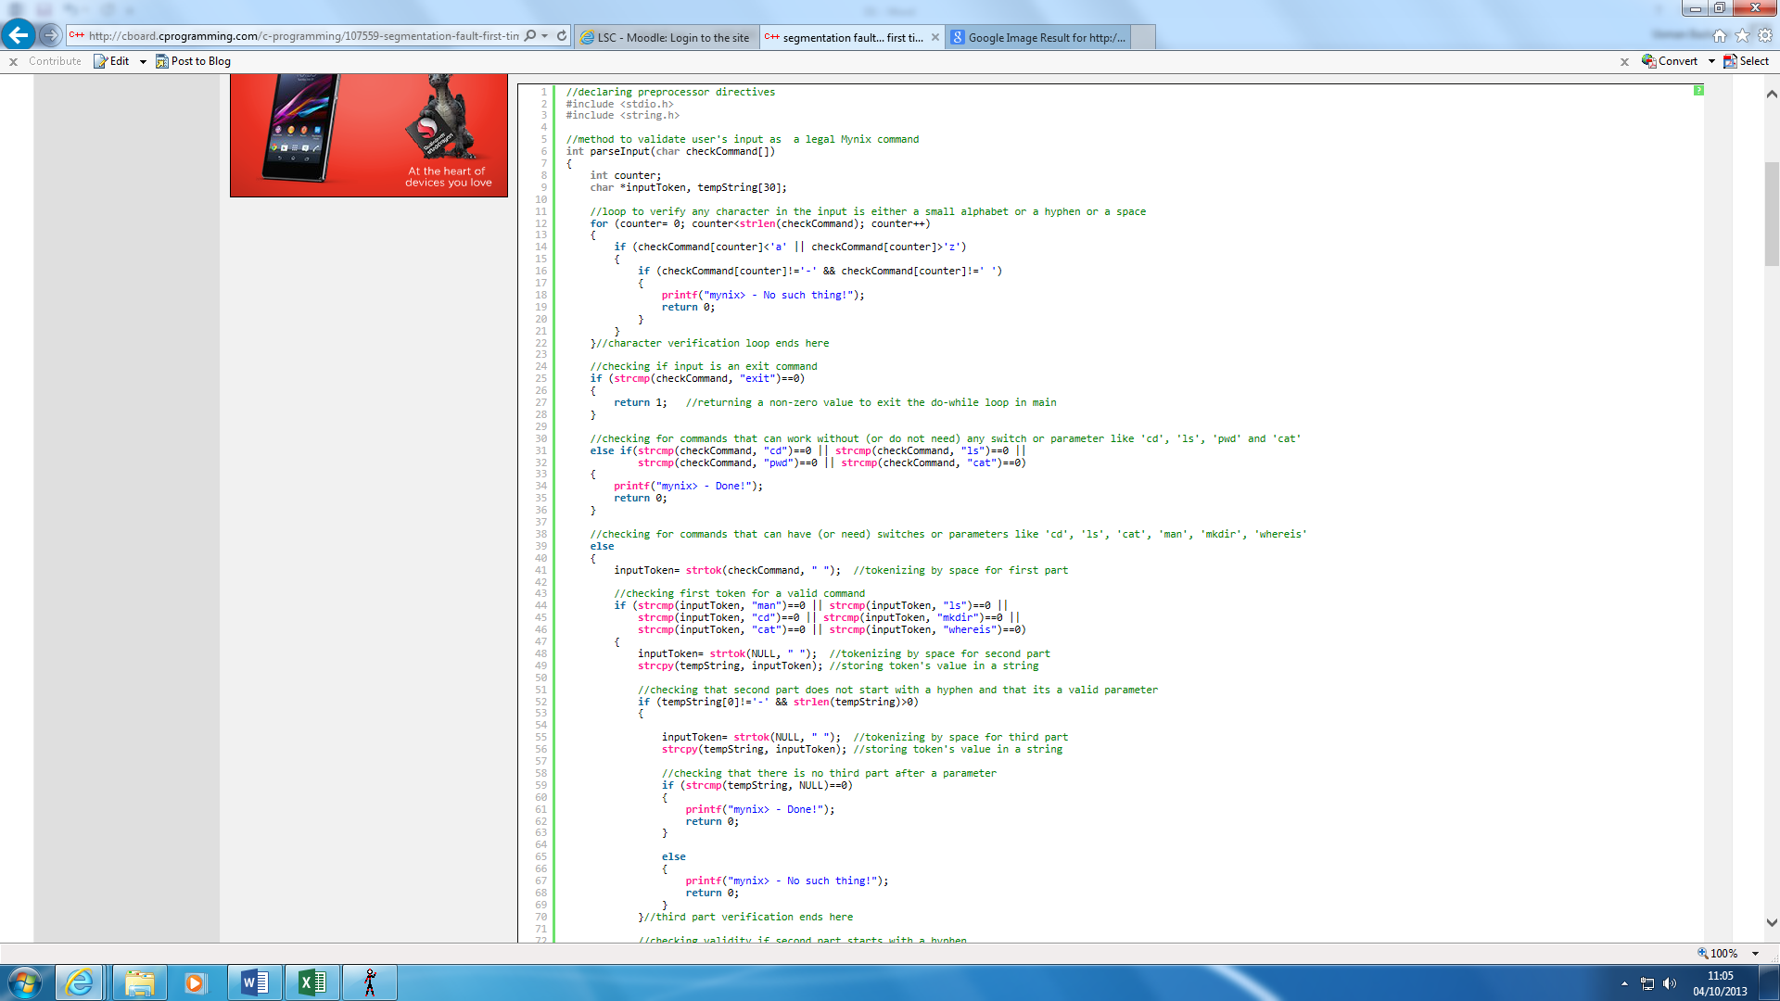

Whereas, here it’s all together and confusing to understand.

[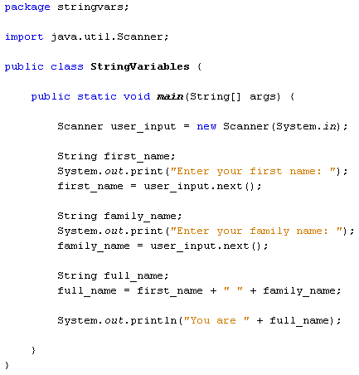](http://www.google.co.uk/url?sa=i&rct=j&q=&esrc=s&frm=1&source=images&cd=&cad=rja&docid=Q-6U4On5WLlnTM&tbnid=l8soTPZ1sdz5LM:&ved=0CAUQjRw&url=http://www.homeandlearn.co.uk/java/user_input.html&ei=VpROUsqYJoL17Aa56oFA&bvm=bv.53537100,d.ZGU&psig=AFQjCNE3QxQMy9wDHRvYelnbLSrmSTmrCA&ust=1380967885211623)

Here for example. Input codes are separated which makes it easier to see.

**Reference**

<http://www.makinggoodsoftware.com/2009/05/04/71-tips-for-naming-variables/>

<http://progopedia.com/example/camelcase/>

<http://visualbasic.about.com/b/2009/11/20/hungarian-notation-revisted.htm>

<http://stackoverflow.com/questions/11141426/custom-emacs-nxml-indentation>

<http://www.brucerick.com/dont-forget-comments-when-programming.html>